**NP 369 CCNA Notes**

[Subnet](https://youtu.be/261J81k_AIA)

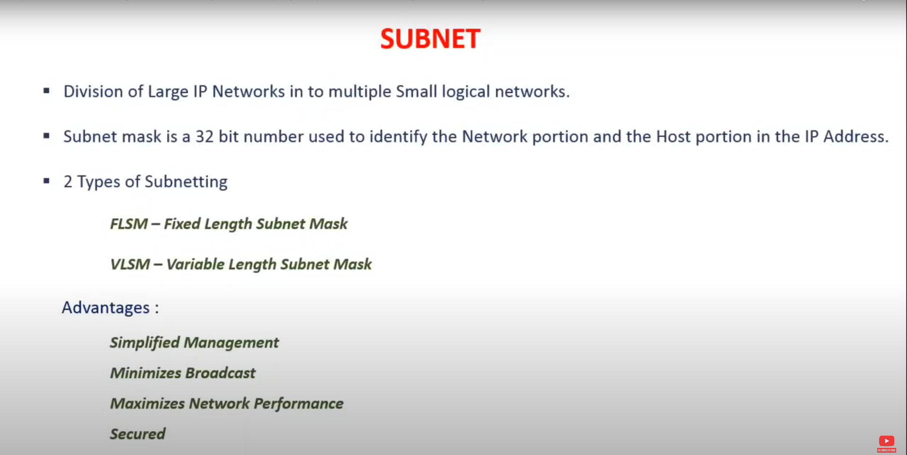

Fixed-Length Subnet Mask - FLSM

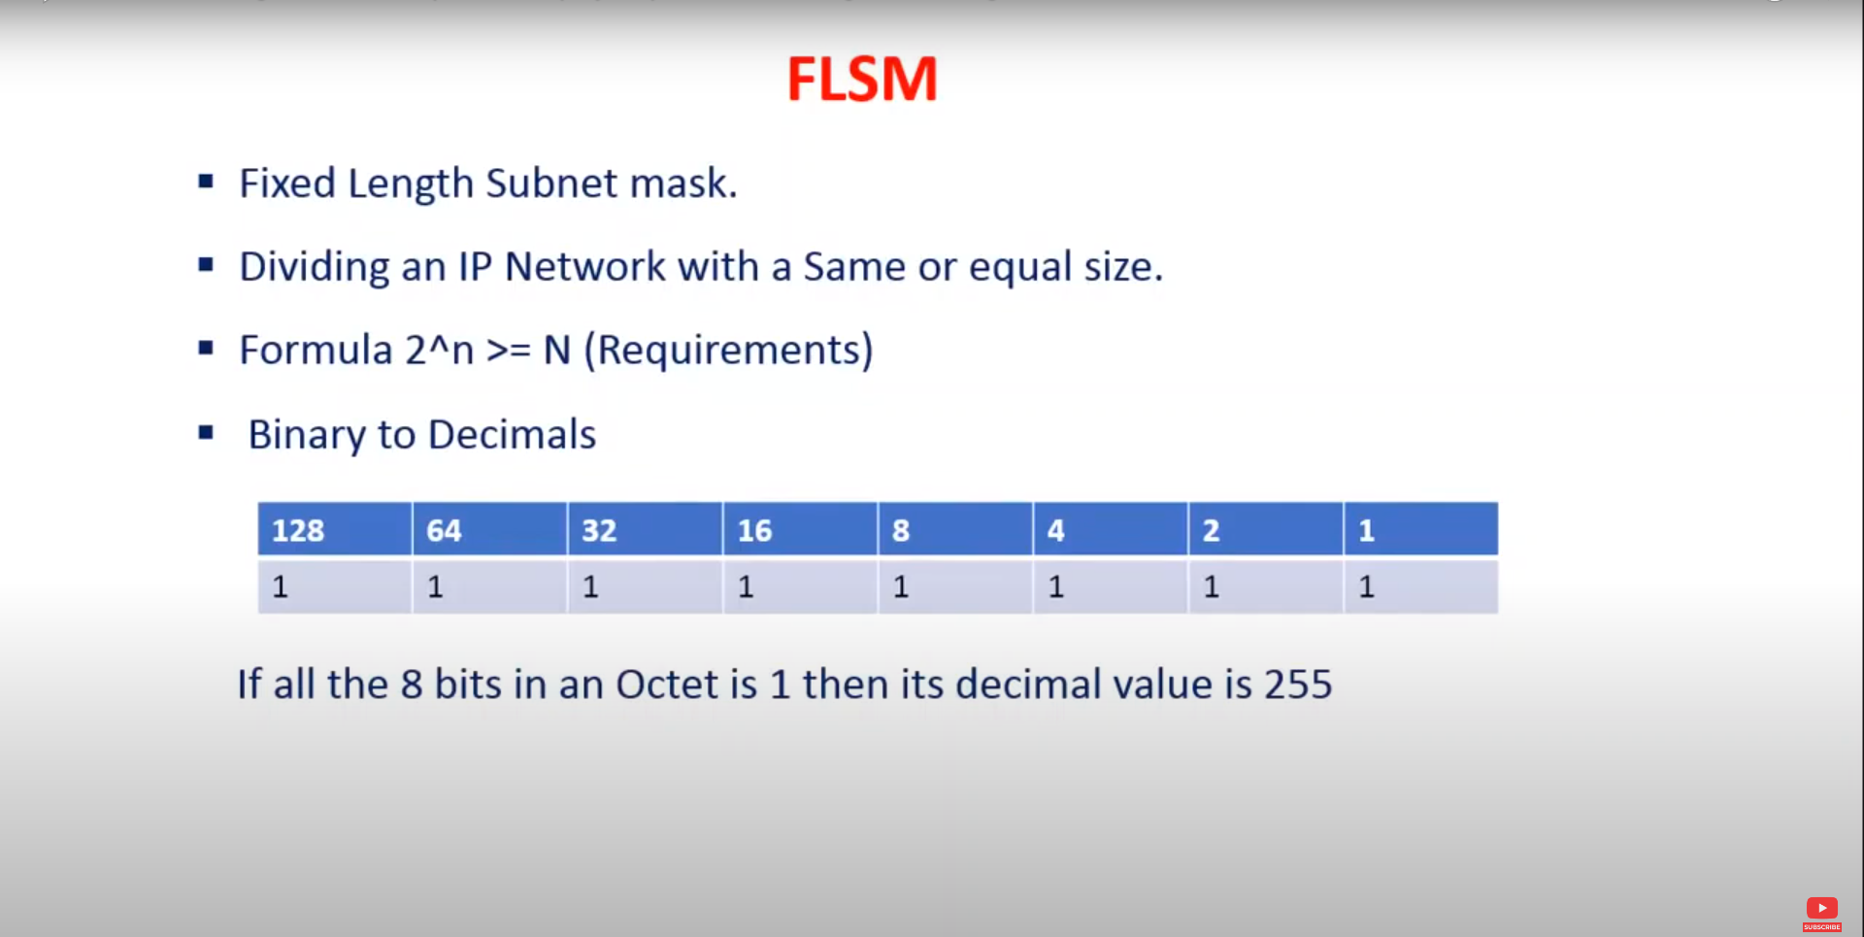

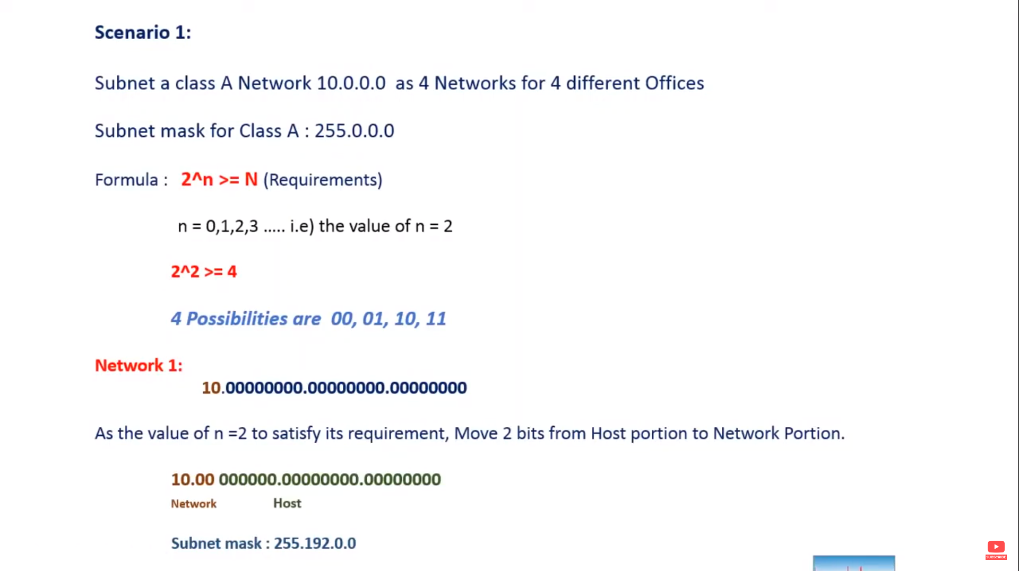

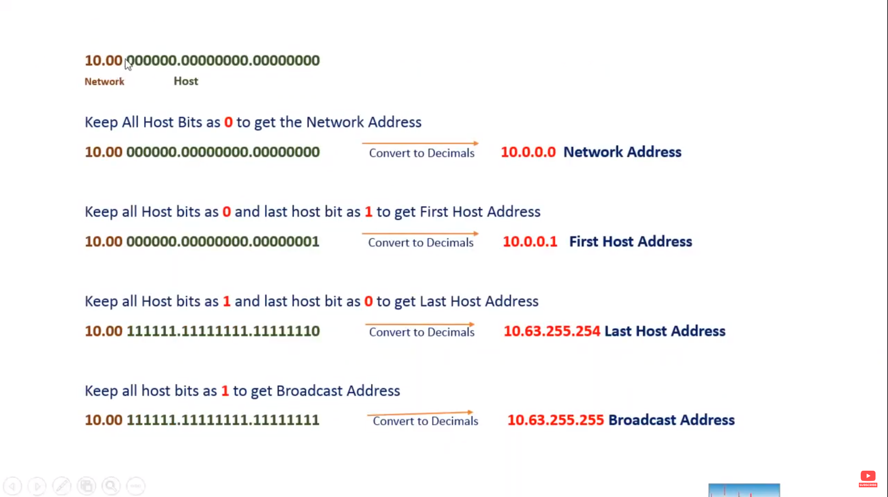

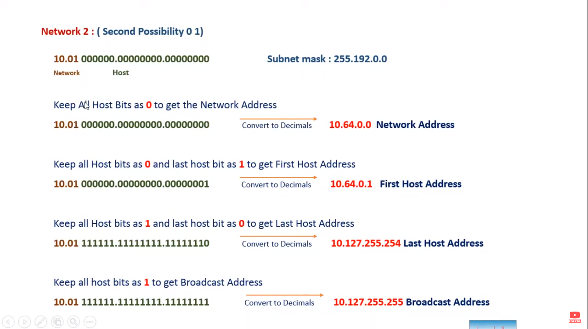

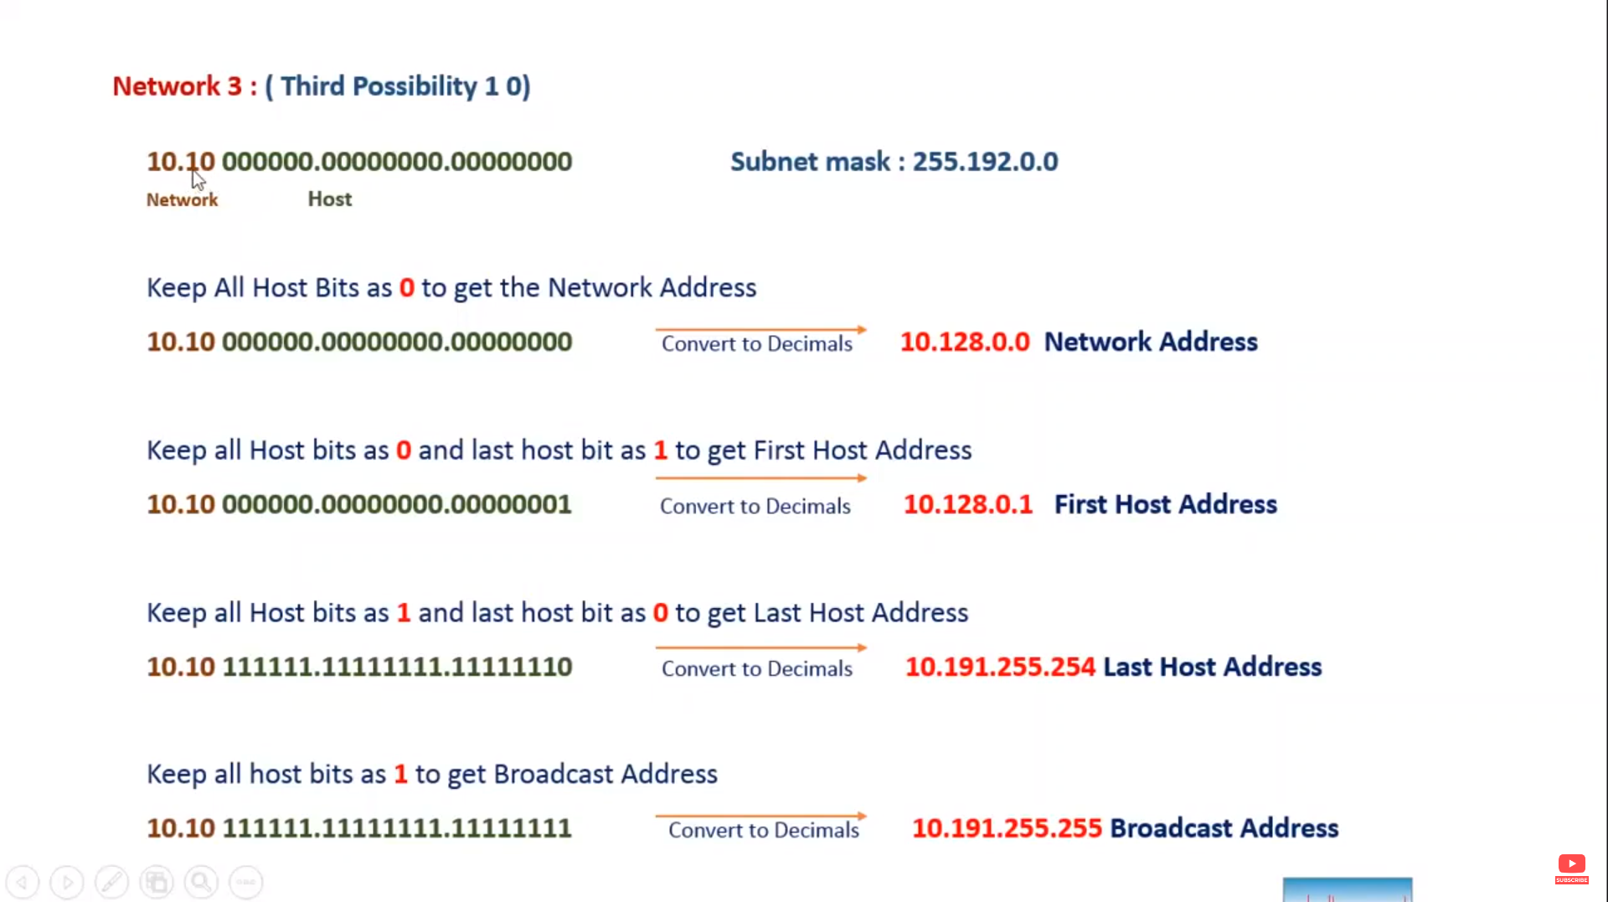

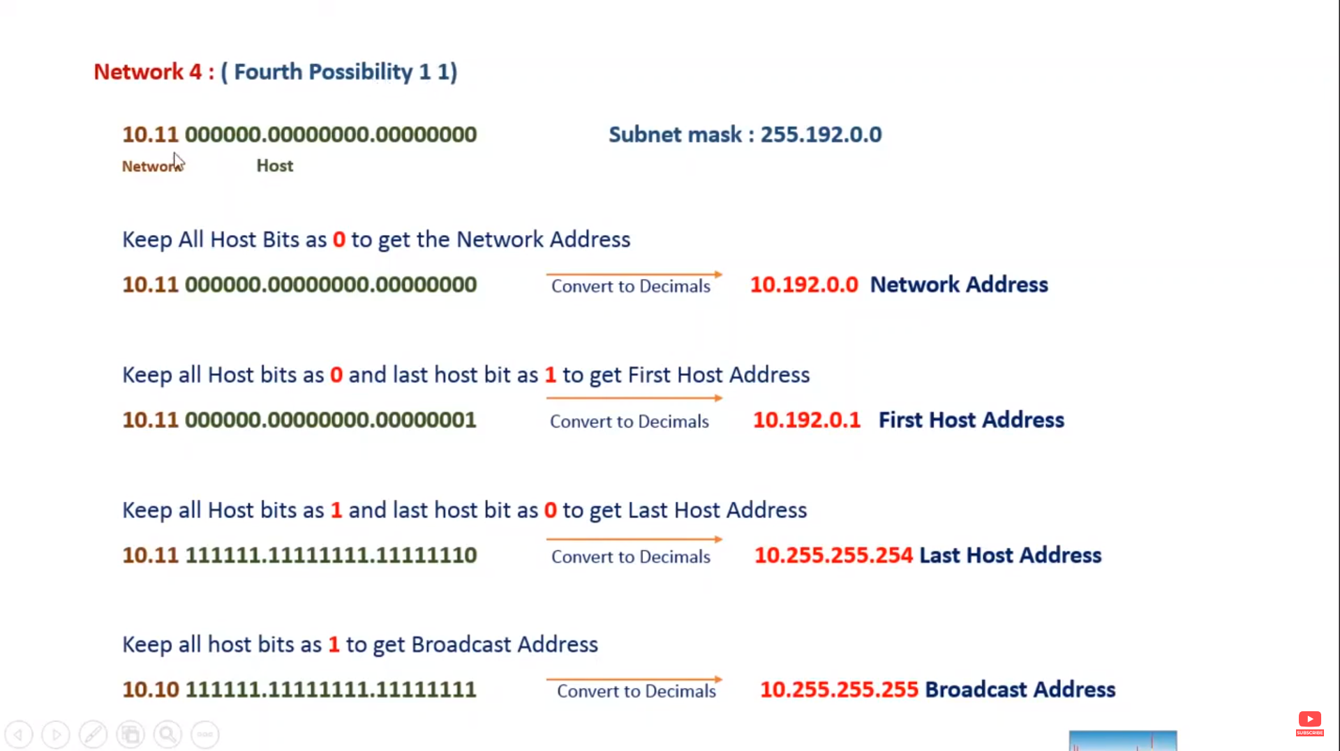

Local Area Network – LAN

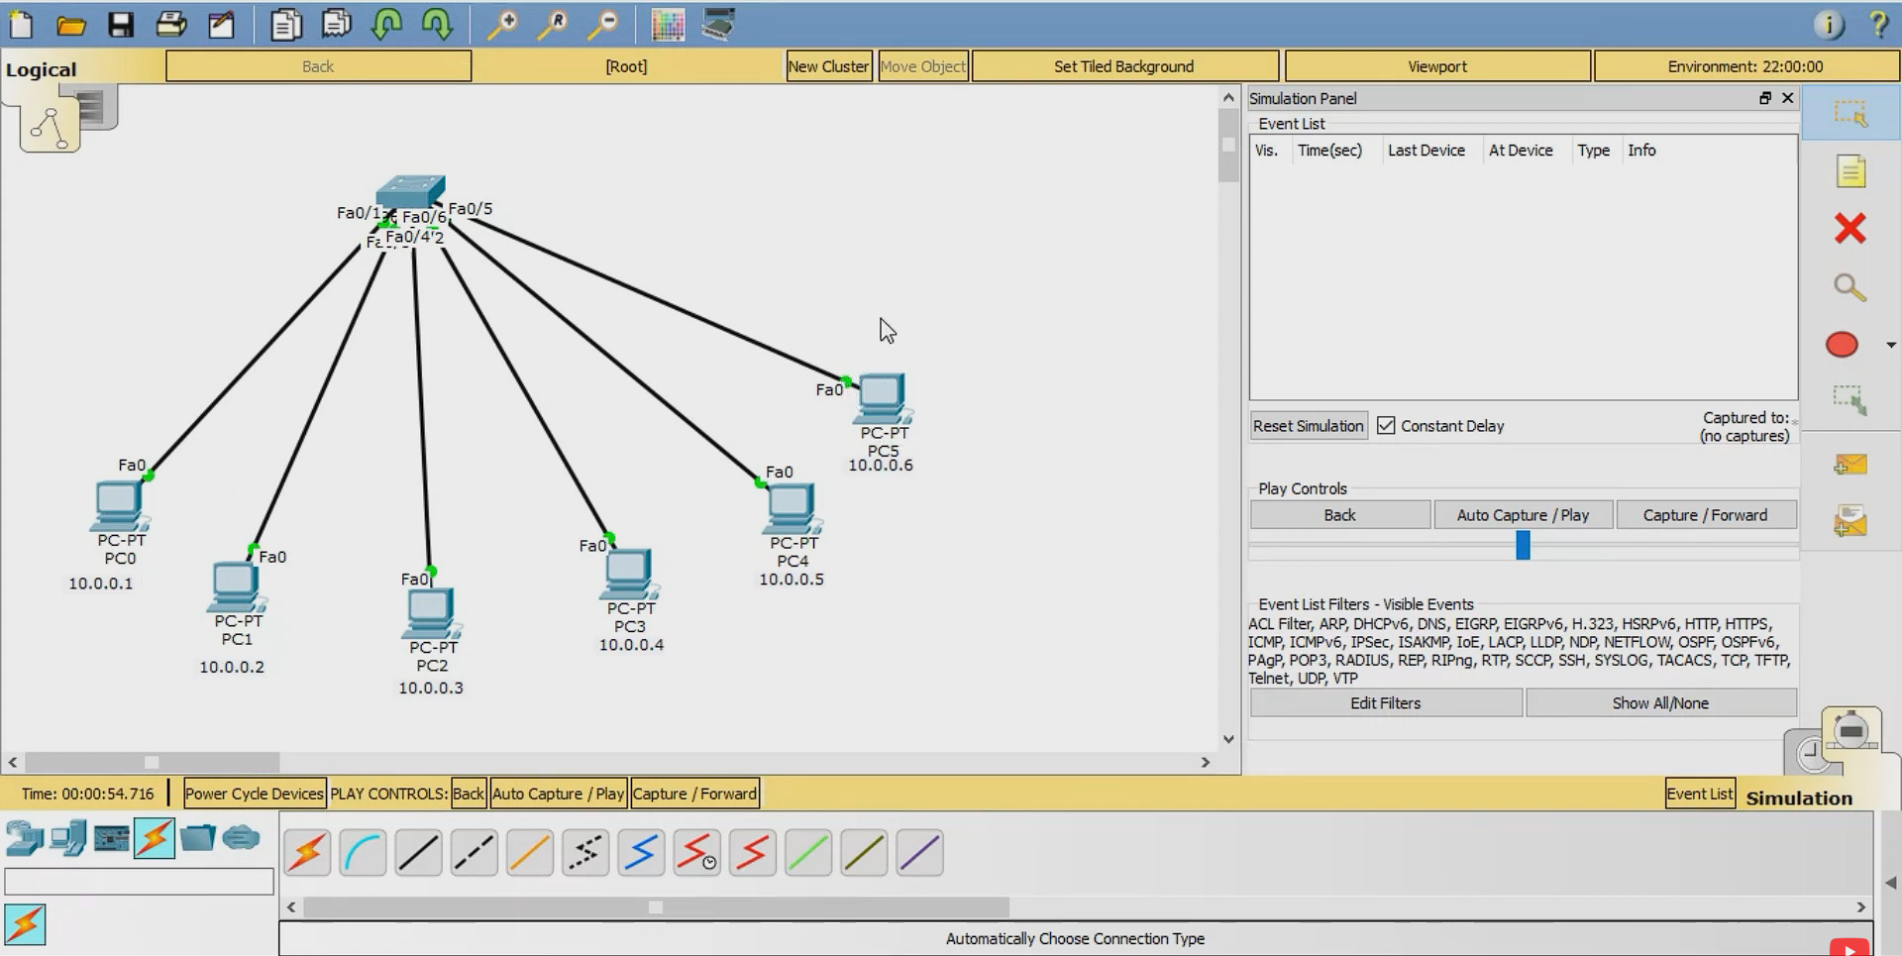

[Virtual Local Area Network - VLAN](https://youtu.be/cqHQbPRKxXA)

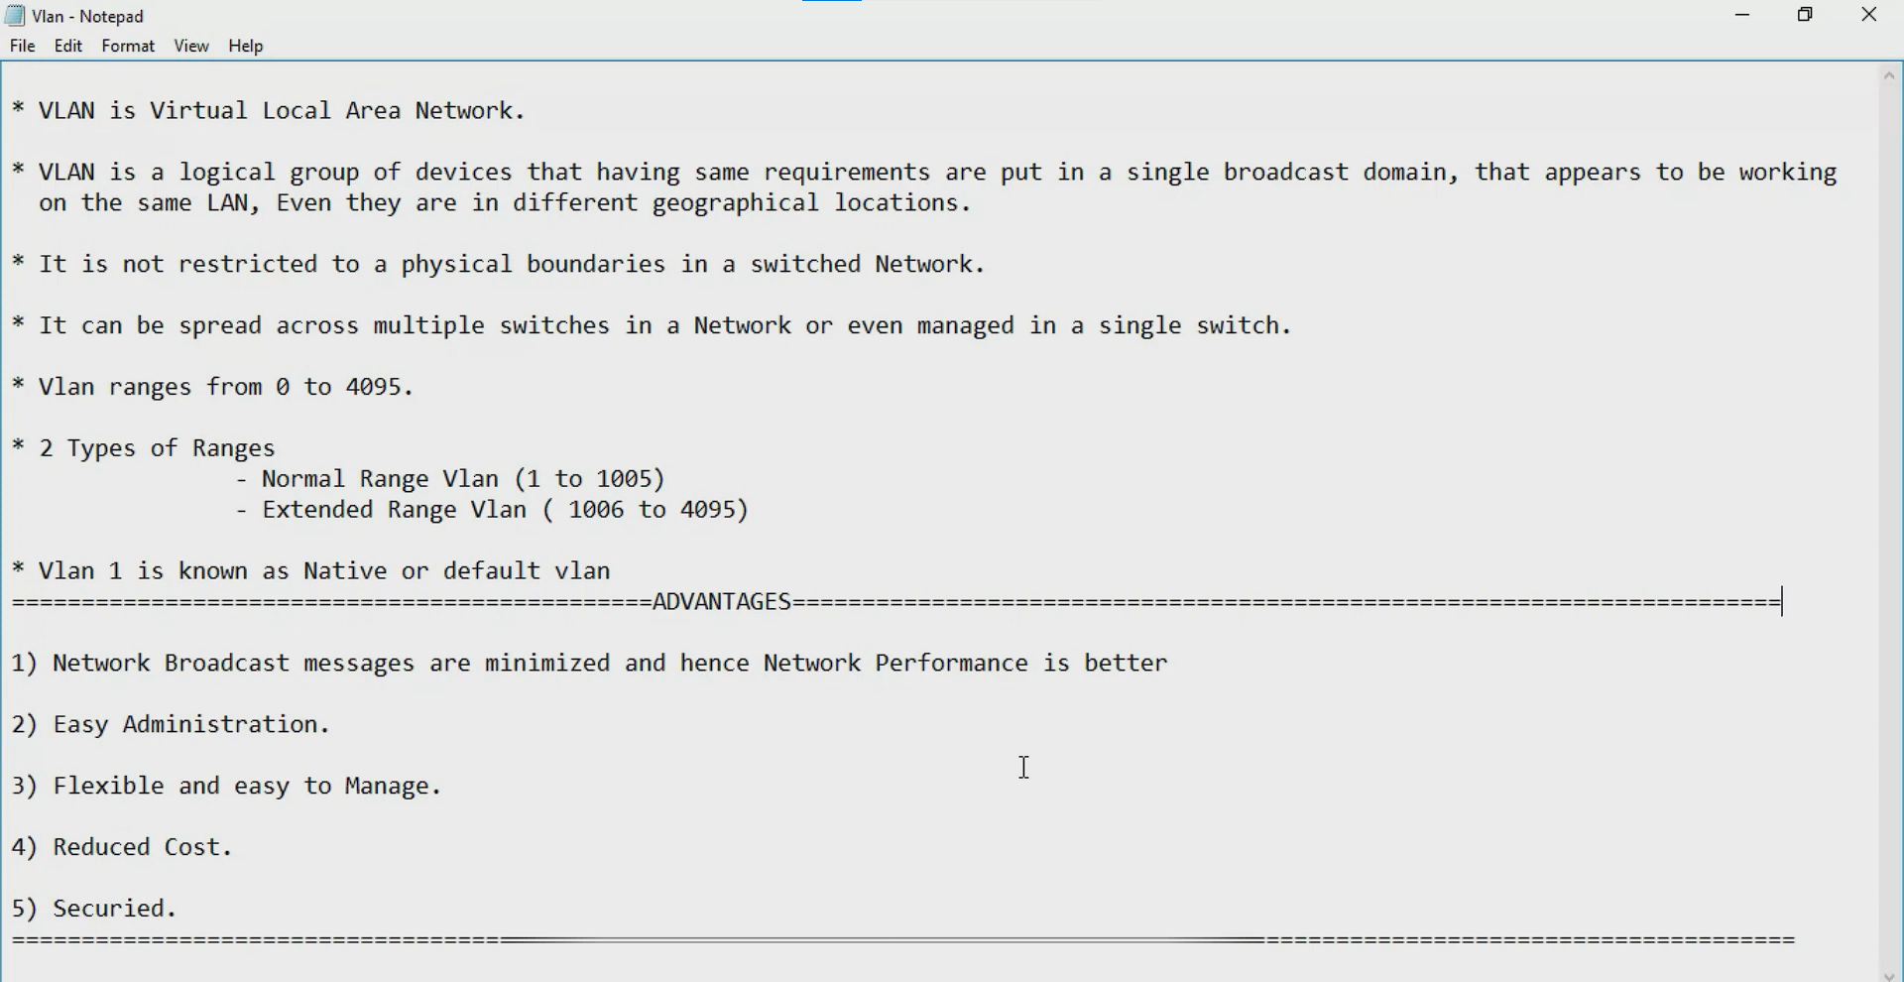

[VLAN Access Port](https://youtu.be/7nUU0bZD0ww)

It allows declared vlan in that port.

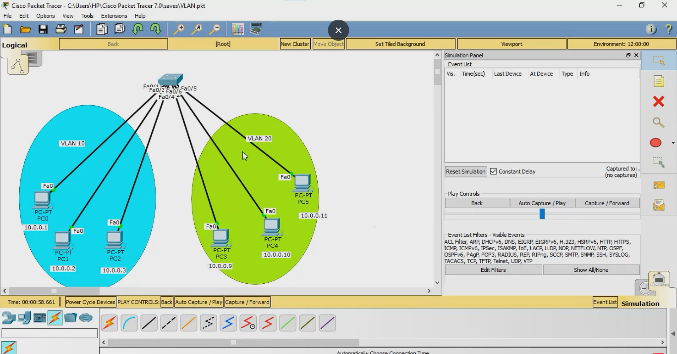

Commands for creating VLAN in switch

1. Show running-config = it show the current running configuration of the switch.
2. Config terminal = to create vlan first get into the configuration mode.
3. Vlan 10 = this vlan 10 is the id of that vlan network. Only numbers are using to create id and that numbers are between 0 to 4095 range only.
4. Name Research and Development = any name can assign and this name is optional.
5. Exit = this exit form the config-vlan mode.
6. Int range fastEthernet 0/1-2 = assigning the already created vlan 10 to interface or port in switch.
7. Switchport mode access = converting the ports to access port for assigning the vlan.
8. Switchport access vlan 10 = passing the vlan 10 id for that port. That means the port allows only vlan 10 network communicate within the vlan 10 network.
9. Exit = exeting for the vlan config mode.
10. Show vlan brief = it shows the vlan details.

[Trunk Port](https://youtu.be/e7v6hvcjui0)

Trunk port allows multiple VLAN in a single port.

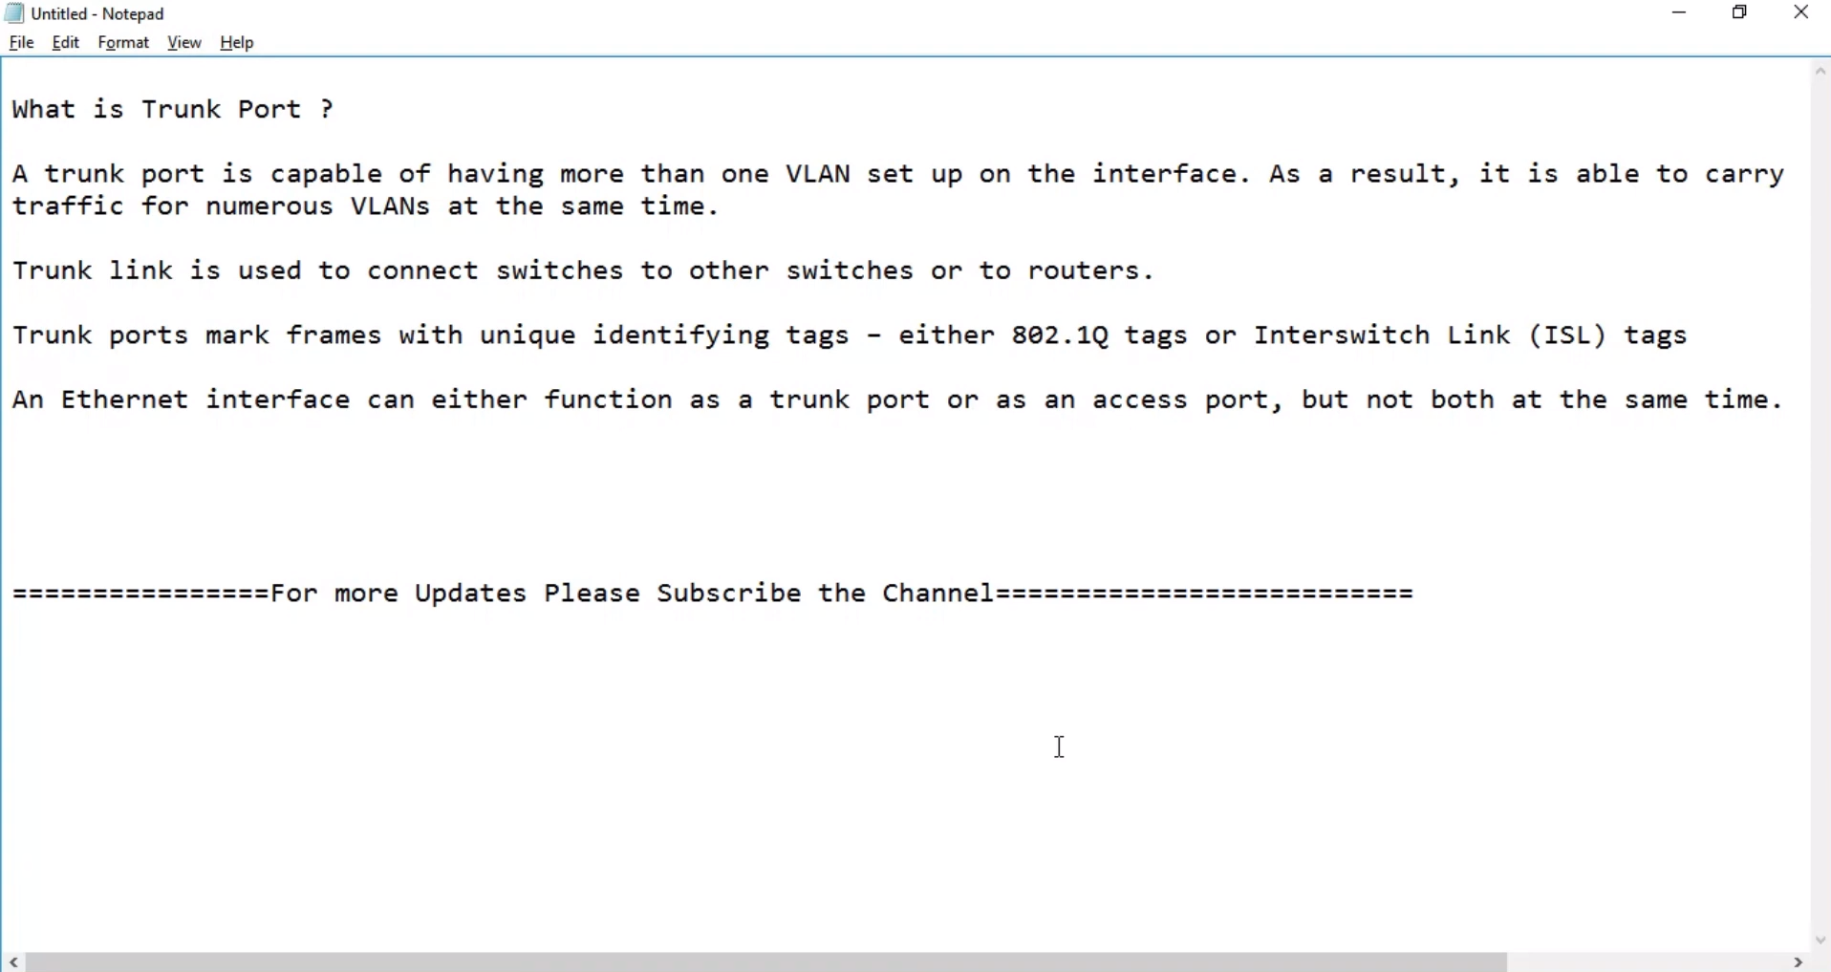

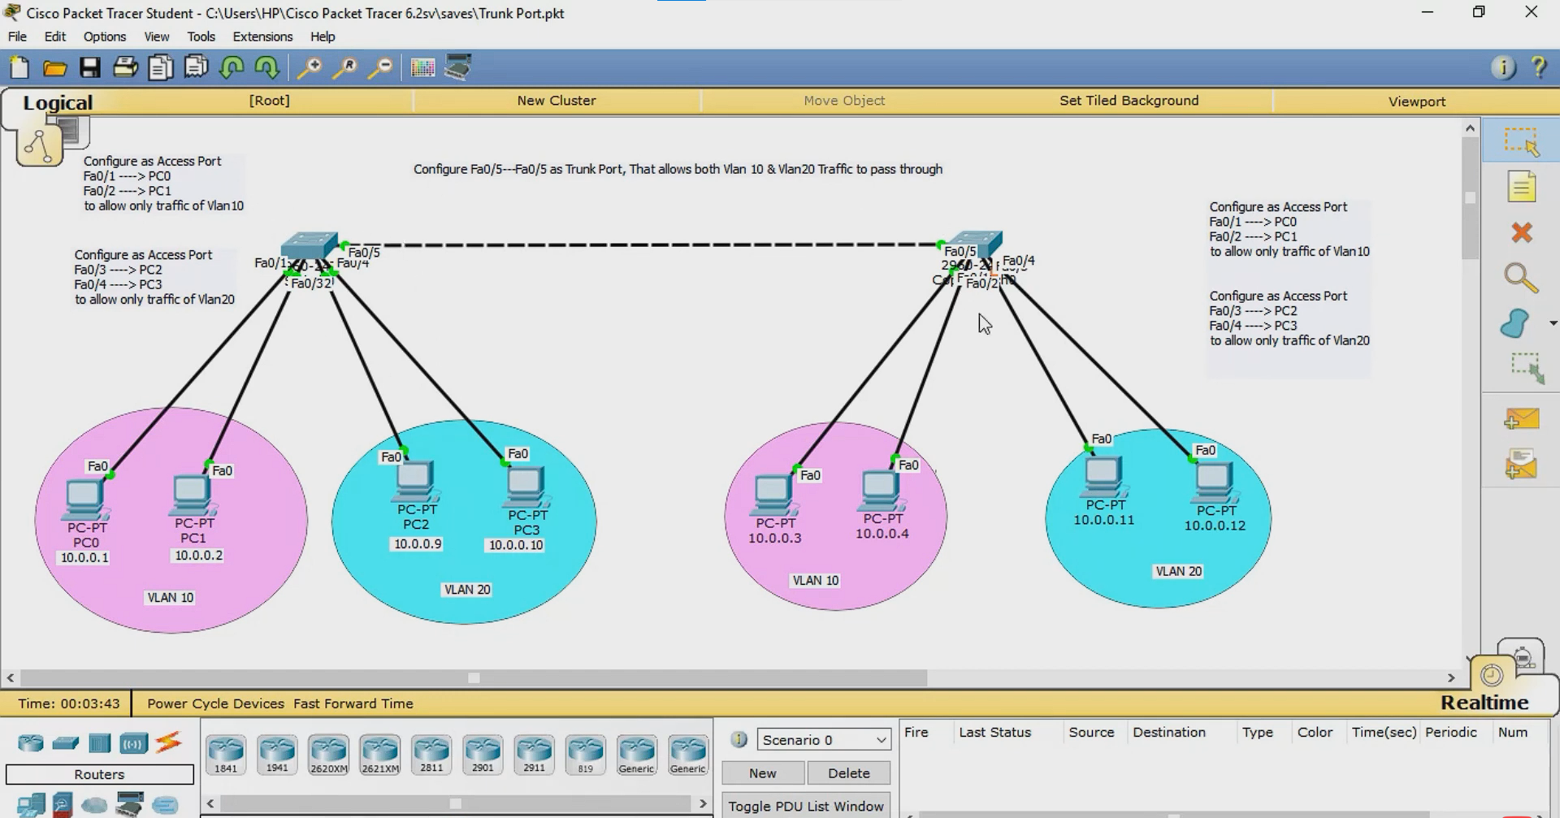

Command to configure Trunk port

1. Config terminal = first want to create vlan so get into the configuration mode.
2. Vlan 10 = this vlan 10 is the id of that vlan network. Only numbers are using to create id and that numbers are between 0 to 4095 range only.
3. Exit = this exit form the config-vlan mode.
4. Interface range fastEthernet 0/1-2 = assigning the already created vlan 10 to interface or port in switch.
5. Switchport mode access = converting the ports to access port for assigning the vlan.
6. Switchport access vlan 10 = passing the vlan 10 id for that port. That means the port allows only vlan 10 network communicate within the vlan 10 network.
7. Exit = exiting for the vlan config mode.
8. Interface fastEthernet 0/5 = selecting the port for configuring that switch port as trunk port.
9. Switchport mode trunk = changing the switch port mode to trunk port mode.
10. Switchport trunk allowed vlan 10,20 = allowing the vlan 10 and vlan 20 in that trunk port.
11. Exit = exiting from the trunk port configuration.
12. Write = write cmd is for save the configuration.
13. Show vlan brief = it show to current running configuration.

[Address Resolution Protocol – ARP](https://youtu.be/rrtzF8awatA)

In local network communication is based on MAC address. So ARP protocol is used to get the MAC address using IP address it is like routing table but not exact routing table.

Example:

In a local network 5 computers are connected to switch. 1st computer want ping with 3rd computer. 1st computer know the 3rd computer ip address but in local network communication is based on the physical address(MAC address) so 1st computer check their arp table weather the destination MAC address is have or not. If not 1st computer want to get the MAC address of the destination computer. For that 1st computer sends the ARP message to switch in that ARP message contains source computer’s IP address and MAC address and destination computer’s IP address and for MAC address is don’t know so source computer but FFFF:FFFF:FFFF:FFFF for broadcast. Now switch recives that ARP Message and broadcast that ARP packet to all computer in that local network. Every computer recives that broadcast packet without source. Then which computer have that exact destination IP address that computer give replay to source in that replay contains addtionally add MAC address of that computer. Now source computer can get the destination computer’s MAC address and save it in source computer’s ( 1st computer’s ARP table) then directly send that ping packet to destination computer (3rd computer) without broadcast.

Show mac address-table = switch shows the mac address-table in enable mode.

[ARP protocol working in other network](https://youtu.be/fsZBfloIEEI) =

https://youtu.be/fsZBfloIEEI

[DHCP & DORA Process](https://youtu.be/RWYhicdqERE)

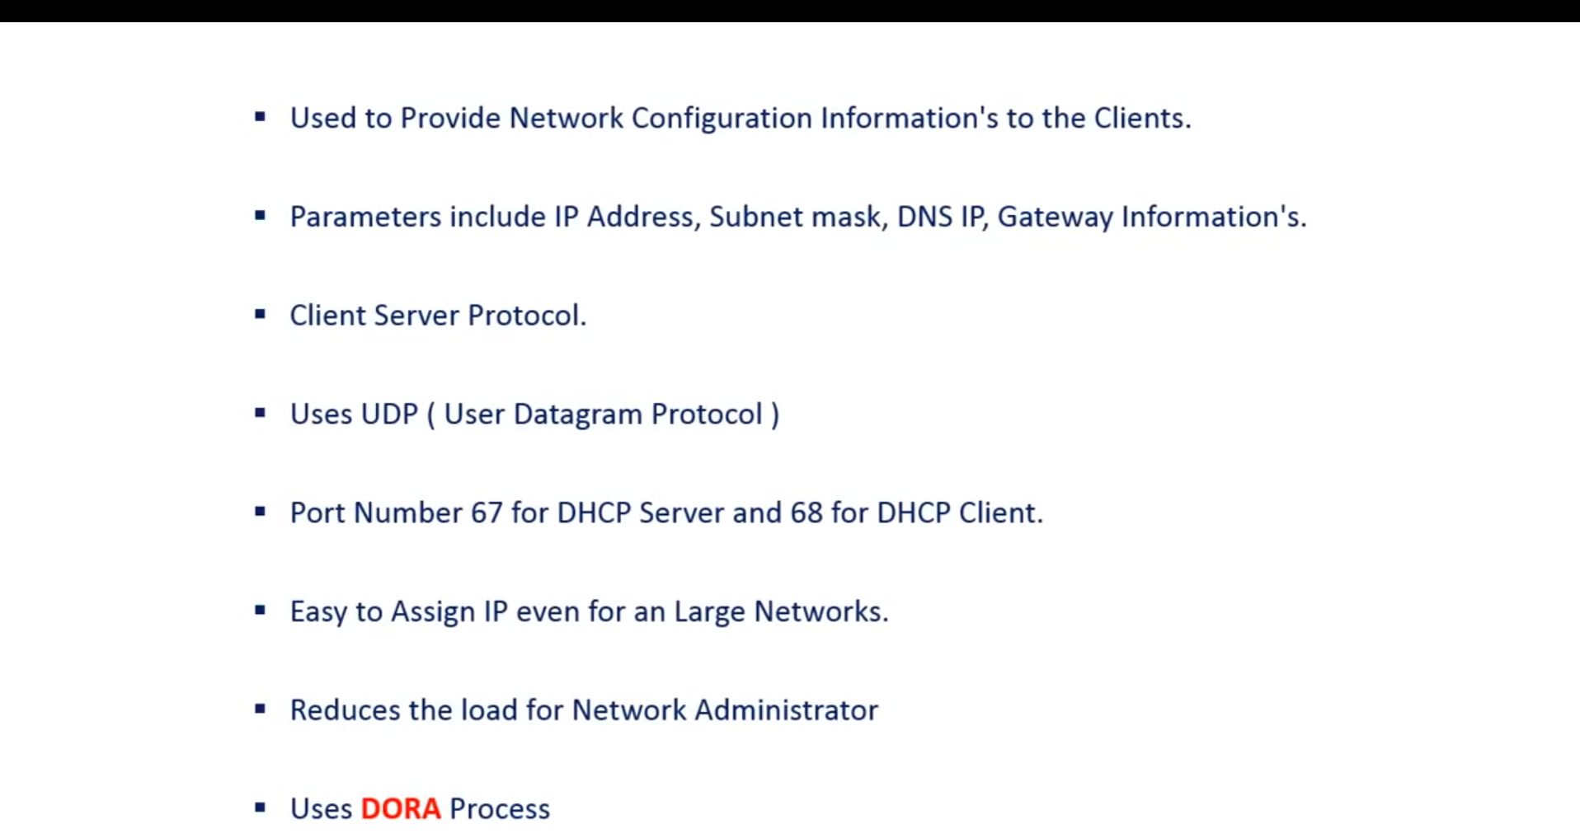

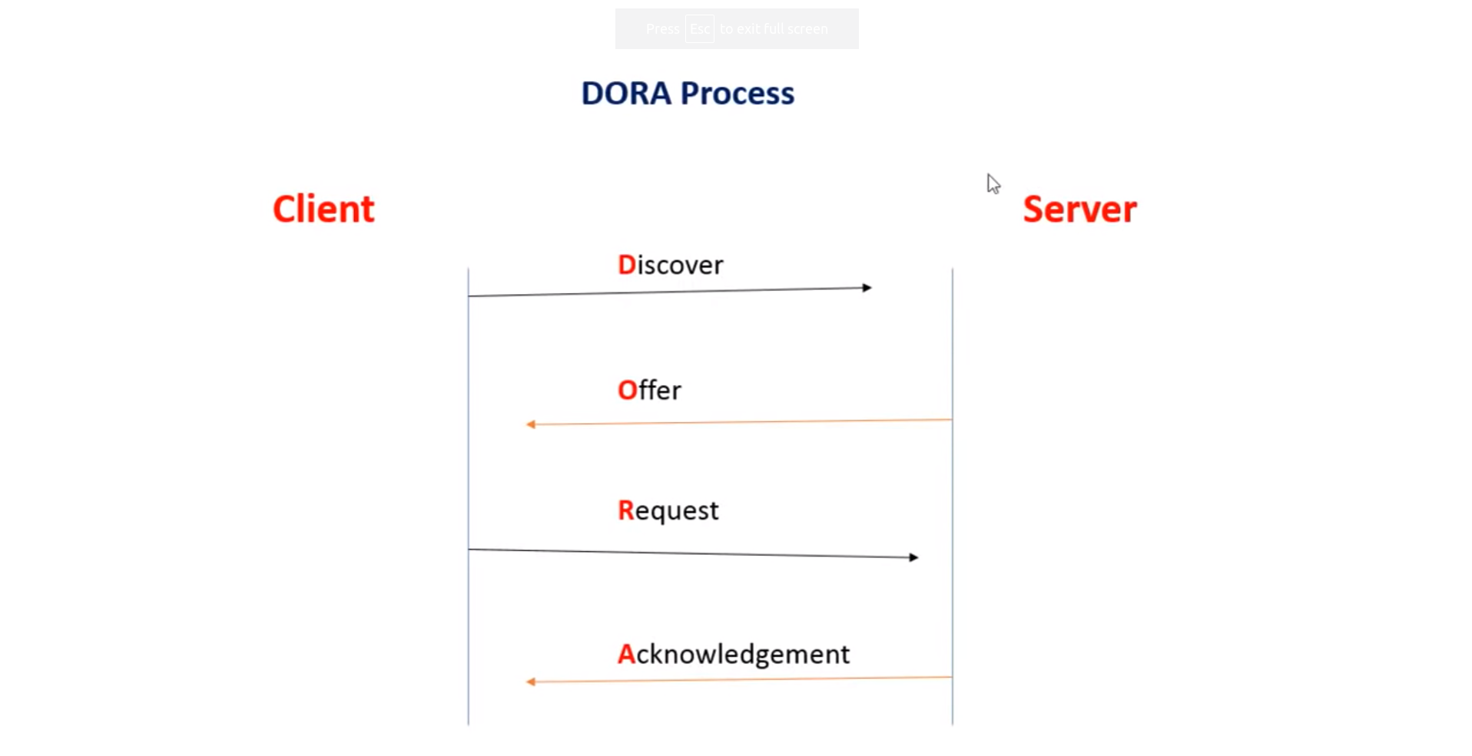1st client broadcast the Discover. After DHCP server recives the discover message.

2nd DHCP server sent the available IP address to client before that DHCP sever check’s whether the IP address is using by any other host in that network by sending the ARP message.

3rd Client recives Offer message. Client send the Request message to DHCP sever to assign the ip address to this device.

4th DHCP server getting the Request message from server. It assign the IP address to Client and DHCP server sent the Ack message to Client this IP address is assigned not only the IP address also Subnet mask address, Default gateway address and DNS address.

DHCP sever use port 67

Client use the port 68

DHCP DORA process all message are send in broadcast only.